Step 1 : First install react-router-dom

In main.jsx add browser router
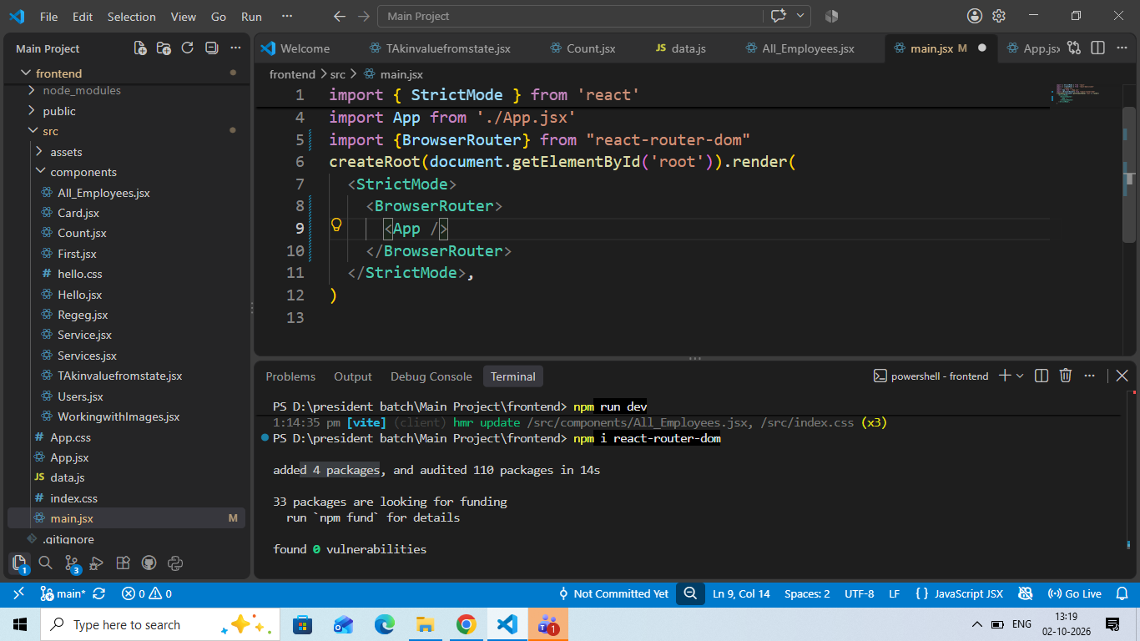
In App.jsx import Route and routes AND WRITE BELOW CODE

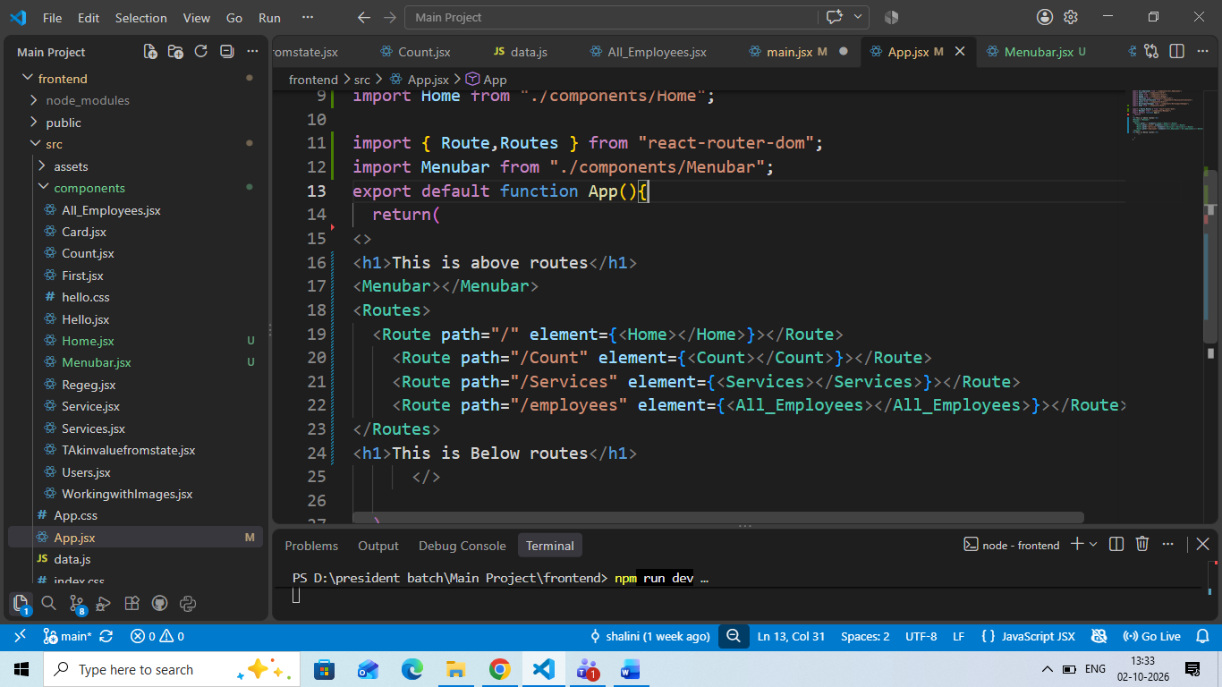

Then Create a Menubar Componet import Link in it

